Table of Contents

1 Zabbix installation: 2

1.1 Design considerations 2

1.2 OS setup 2

1.2.1 SELinux configuration 2

1.2.2 Firewall configuration: 2

1.2.3 Kernel configuration: 2

1.3 Installation from repositories (RedHat/CentOS/Oracle Linux) 3

1.4 Installation from sources (not recommended) 3

1.5 Additional configuration 4

1.6 Zabbix repository/database configuration 5

1.6.1 PostgreSQL 5

1.6.2 MySQL 6

1.6.3 Oracle 6

1.7 Zabbix server configuration 6

1.7.1 Startup and enable autostart 6

1.7.2 Web interface 6

1.7.3 Zabbix configuration through web interface 7

1.8 Grafana installation (visualization and analytics) 11

1.8.1 Install from repository 11

1.8.2 Install Zabbix-Grafana plugin 11

1.9 HA and DR considerations and options 12

1.10 Zabbix agent installation and configuration 12

1.10.1 Windows 12

1.10.2 Linux 12

1.10.3 Copy zbxpwsh scripts to D:\DBA\ or /opt/ 12

1.10.4 Modify zabbix_agentd.conf 12

2 Oracle Monitoring 12

3 MSSQL Monitoring 13

4 DB2 Monitoring 13

4.1 4.1 Install DB2 client 13

5 PostgreSQL Monitoring 13

6 MySQL monitoring 13

# Zabbix installation:

## Design considerations

Multi master setup (with number of active nodes running) is not supported ([removed in 2.4](https://www.zabbix.com/documentation/2.4/manual/introduction/whatsnew240#node-based_distributed_monitoring_removed))

HA configuration normally involves CoroSync setup for Zabbix server and appropriate solution for database backend (Streaming Replication/PgPool for PostgreSQL, Galera Clustering for MySQL/MariaDB, Data Guard for Oracle Database)

## OS setup

### OS configuration

# hostnamectl set-hostname zbx-server

# timedatectl set-timezone Australia/Adelaide

### SELinux configuration

Set it to permissive as starting point. For more options – check documentation

Update /etc/selinux/config to make persistent change

# sed -i 's/SELINUX=enforcing/SELINUX=permissive/' /etc/selinux/config

Update settings for currently running OS

# setenforce Permissive

# getenforce

Permissive

### Firewall configuration:

# firewall-cmd --add-port=10051/tcp --zone=public --permanent

success

# firewall-cmd --add-service=http --zone=public --permanent

success

# firewall-cmd –reload

success

### Kernel configuration:

Check parameter kernel.shmmax

https://www.zabbix.org/wiki/How_to/configure_shared_memory

## Installation from repositories (RedHat/CentOS/Oracle Linux)

Add Zabbix repository (Change version accordingly)

<https://www.zabbix.com/documentation/3.0/manual/installation/install_from_packages/repository_installation>

# yum -y install http://repo.zabbix.com/zabbix/4.3/rhel/7/x86_64/[zabbix-release-4.3-3.el7.noarch.rpm](http://repo.zabbix.com/zabbix/4.3/rhel/7/x86_64/zabbix-release-4.3-3.el7.noarch.rpm)

Add repository and install Zabbix packages, using yum (with PostgreSQL as backend):

# yum -y install zabbix-server-pgsql zabbix-web-pgsql zabbix-agent

Add repository for PostgreSQL and install server (or use yum local install) (or build from sources) (example is for CentOS and PG10)

<https://yum.postgresql.org>

# yum -y install https://download.postgresql.org/pub/repos/yum/11/redhat/rhel-7.6-x86_64/p[gdg-redhat-repo-latest.noarch.rpm](https://download.postgresql.org/pub/repos/yum/11/redhat/rhel-7.6-x86_64/pgdg-redhat-repo-latest.noarch.rpm)

# yum -y install postgresql11-server.x86_64

## Installation from sources (not recommended)

Additional tools and packages required for compilation

# yum -y install git autoconf automake libtool

# yum -y install zlib-devel openssl-devel libxml2-devel

# yum -y install libevent libevent-devel

Build curl (required for web monitoring)

# git clone https://github.com/curl/curl

# cd curl

# ./buildconf

# ./configure --prefix=/opt/curl CFLAGS='-O2'

# make

# make install

PostgreSQL build

Check versions for relevance

# wget https://ftp.postgresql.org/pub/source/v10.2/postgresql-10.2.tar.bz2

# bunzip postgresql-10.2.tar.bz2

# ./configure --prefix=/opt/postgresql/10.2 --without-readline --with-openssl --with-libxml CFLAGS='-O2 -pipe'

# make

# make install

Zabbix build

# wget https://sourceforge.net/projects/zabbix/files/ZABBIX%20Latest%20Stable/3.4.7/zabbix-3.4.7.tar.gz/download

# ./configure --enable-server --enable-agent --with-postgresql=/opt/postgresql/10.2/bin/pg_config --prefix=/opt/zabbix --with-libcurl=/opt/curl/bin/curl-config CFLAGS='-O2'

# make

# make install

## Additional configuration

Update postgres user profile, add PATH to .bash_profile and modify PGDATA variable if required (beware of Word’s quota marks and dashes!)

echo 'export PATH=$PATH:/usr/pgsql-11/bin' >> ~postgres/.bash_profile

echo 'export PGDATA=/pgsql/11/data' >> ~postgres/.bash_profile

Create storage volume for database if required:

# pvcreate /dev/sdb

Physical volume "/dev/sdb" successfully created.

# vgcreate pgsqlvg /dev/sdb

Volume group "pgsqlvg" successfully created

# vgdisplay pgsqlvg

[…]

Total PE 12799

[…]

# lvcreate -l 6399 --name datavol pgsqlvg

Logical volume "datavol" created.

# mkfs.xfs /dev/mapper/pgsqlvg-datavol

# mkdir /pgsql

Add new filesystem to /etc/fstab, mount, create directories and change ownership

# echo "/dev/mapper/pgsqlvg-datavol /pgsql xfs defaults 0 0" >> /etc/fstab

# mount -a

# mkdir -p /pgsql/11/data

# chown -R postgres:postgres /pgsql

## Zabbix repository/database configuration

### PostgreSQL

Create database:

# su - postgres -c 'pg_ctl init -D $PGDATA'

Check OS shared memory settings if required

<https://www.postgresql.org/docs/11/static/kernel-resources.html>

Modify PostgreSQL configuration file /pgsql/data/postgresql.conf in accordance with configuration standards (listen_addresses, shared_buffers, huge_pages, temp_buffers, archive_mode, archive_command, max_wal_senders)

Check if /etc/systemd/system/postgresql-server.service or similar exists and if it does not exist – create it

<https://www.postgresql.org/docs/devel/static/server-start.html>

# Location of database directory

Environment=PGDATA=/pgsql/11/data/

Paths in red are location of PostgreSQL database cluster location, modify if required

# systemctl daemon-reload

# systemctl start postgresql-11

# systemctl enable postgresql-11

Created symlink from /etc/systemd/system/multi-user.target.wants/postgresql-server.service to /etc/systemd/system/postgresql-server.service.

Create database user zabbix

# sudo su - postgres -c 'createuser --pwprompt zabbix'

Enter password for new role:

Enter it again:

Create database zabbix using createdb

# sudo su - postgres -c 'createdb -O zabbix zabbix'

Create database objects using provided scripts

# sudo su - postgres -c "zcat /usr/share/doc/zabbix-server-pgsql-$(rpm -qa zabbix-server-pgsql | awk -F'-' '{print $4}')/create.sql.gz | psql -U zabbix zabbix"

#### Timescale DB

https://www.zabbix.com/documentation/4.2/manual/introduction/whatsnew420#timescaledb_support

### MySQL

To be added if required

### Oracle

To be added if required

## Zabbix server configuration

### Startup and enable autostart

# systemctl start zabbix-server

# systemctl enable zabbix-server

Created symlink from /etc/systemd/system/multi-user.target.wants/zabbix-server.service to /usr/lib/systemd/system/zabbix-server.service.

# systemctl start zabbix-agent

# systemctl enable zabbix-agent

Created symlink from /etc/systemd/system/multi-user.target.wants/zabbix-agent.service to /usr/lib/systemd/system/zabbix-agent.service.

### Web interface

Update PHP parameters /etc/httpd/conf.d/zabbix.conf

# vi /etc/httpd/conf.d/zabbix.conf

php_value memory_limit 256M

php_value date.timezone Australia/Adelaide

Start and enable httpd:

# systemctl start httpd

# systemctl enable httpd

Created symlink from /etc/systemd/system/multi-user.target.wants/httpd.service to /usr/lib/systemd/system/httpd.service.

### Zabbix configuration through web interface

By default Zabbix server is configured by using web page, connect to <hostname>/zabbix using web browser

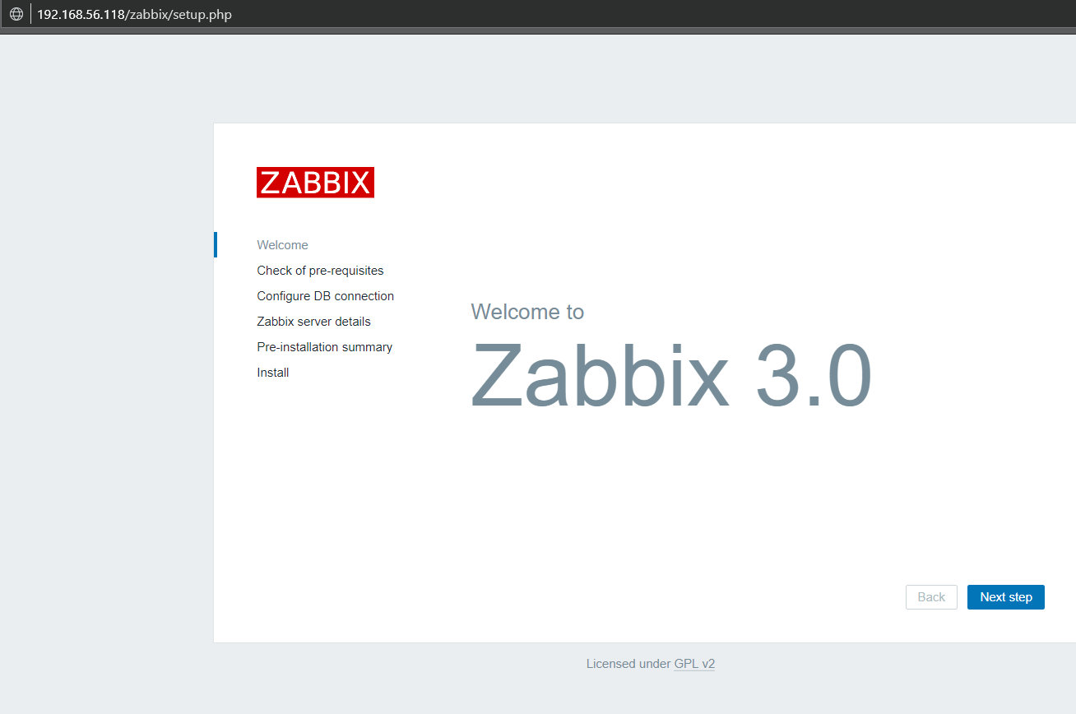

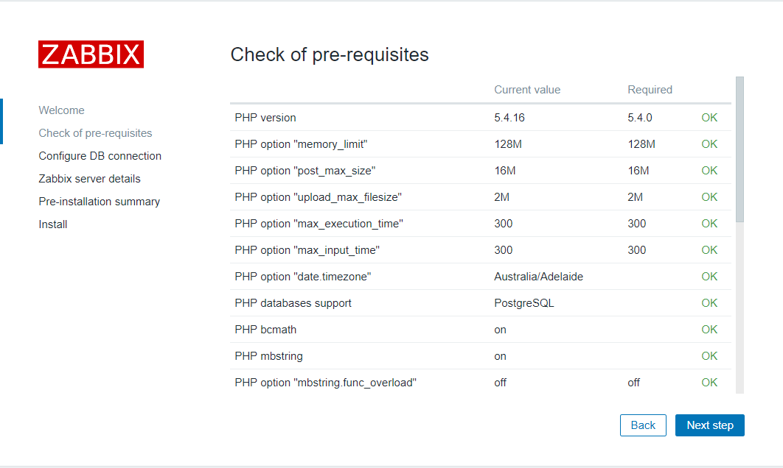 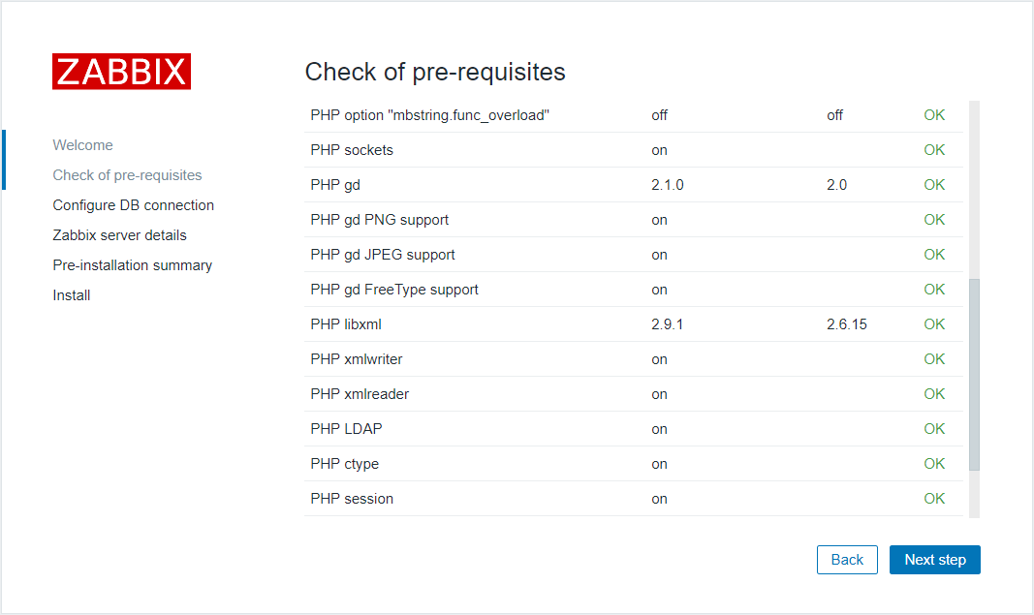

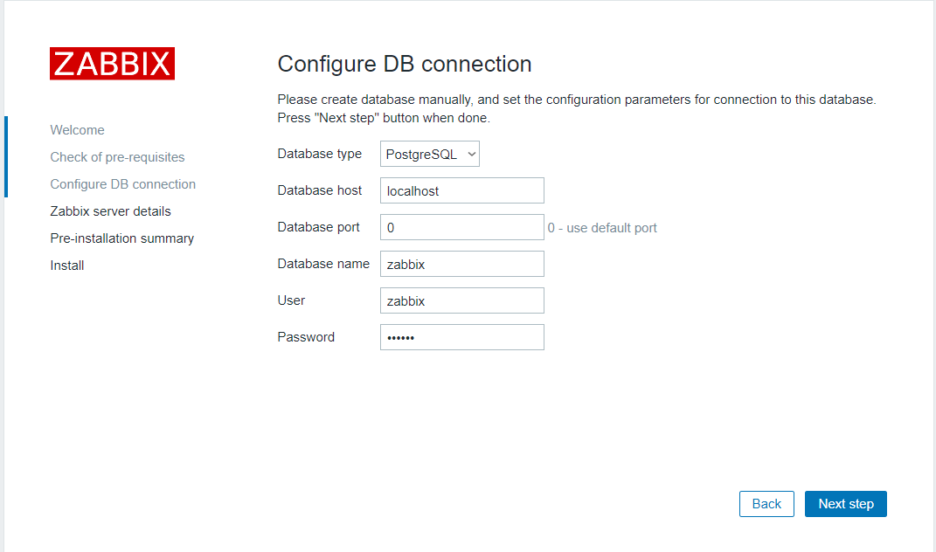

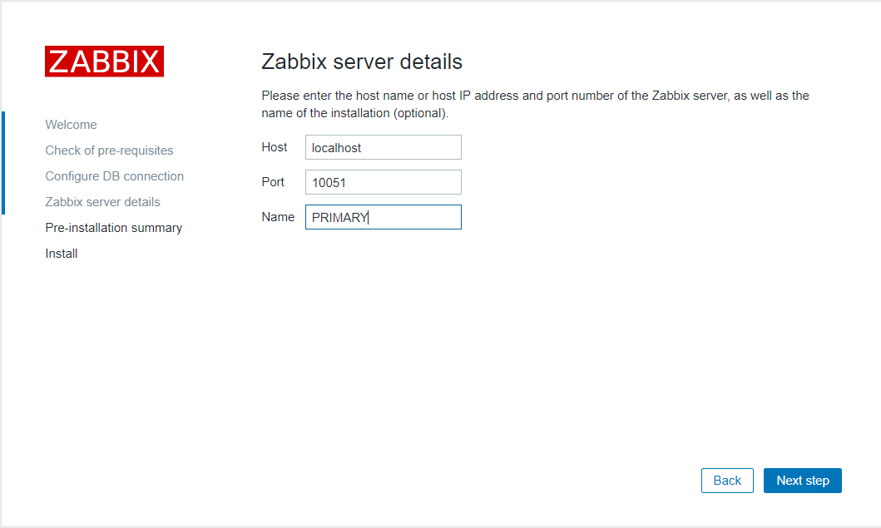

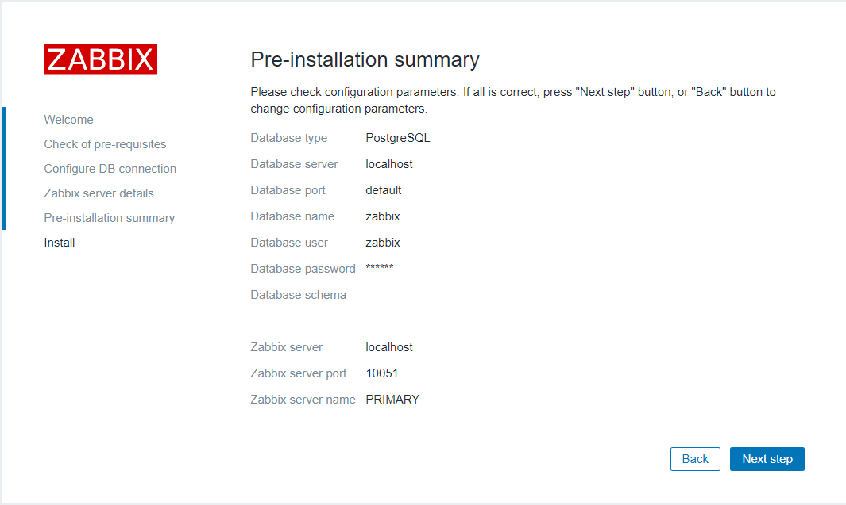

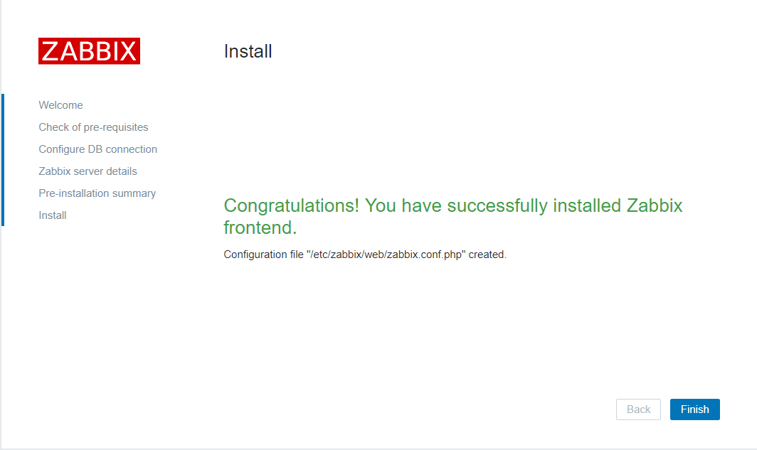

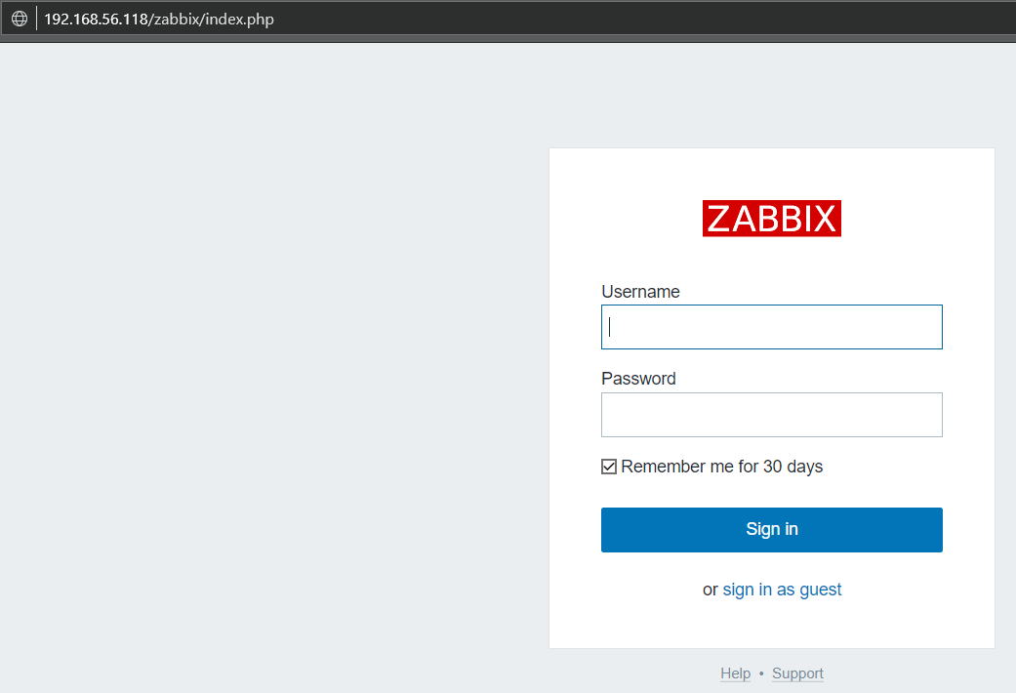

Default user: Admin/zabbix

How to change Logo:

<http://yallalabs.com/monitoring-tools/zabbix-how-to-change-logo-in-zabbix-3-x>

## Grafana installation (visualization and analytics)

### Install from repository

Install Grafana, check for the latest package (<https://grafana.com/grafana/download?platform=linux>)

wget <https://dl.grafana.com/oss/release/grafana-6.3.3-1.x86_64.rpm>

### Install Zabbix-Grafana plugin

https://grafana.com/plugins/alexanderzobnin-zabbix-app/installation

<http://docs.grafana-zabbix.org/installation/>

# grafana-cli plugins install alexanderzobnin-zabbix-app

installing alexanderzobnin-zabbix-app @ 3.10.4

from: https://grafana.com/api/plugins/alexanderzobnin-zabbix-app/versions/3.10.4/download

into: /var/lib/grafana/plugins

✔ Installed alexanderzobnin-zabbix-app successfully

Restart grafana after installing plugins . <service grafana-server restart>

# service grafana-server restart

Enable it and configure pointing to Zabbix REST API https://<zabbix>/

## HA and DR considerations and options

PostgreSQL standby database

Corasync/Pacemaker

## Zabbix agent installation and configuration

### Windows

Download latest version of agent and install it manually or using available automated tools

<http://www.suiviperf.com/zabbix/index.php>

### Linux

Download and install the latest version of Zabbix agent using yum from repository manually or using available automated tool

Install PowerShell

### Copy zbxpwsh scripts to D:\DBA\ or /opt/

### Modify zabbix_agentd.conf

See zabbix_agentd.conf.example

# Oracle Monitoring

Separate install of Oracle agent is not required

# MSSQL Monitoring

# DB2 Monitoring

## 4.1 Install DB2 client

# PostgreSQL Monitoring

Separate install of Postgresql libraries is not required

# MySQL monitoring